

**Combined Display Day with Sprite Club of SA**

**Sunday 3rd November 2024 – Wigley Reserve, Glenelg**

The Sprite Club of South Australia and The Austin Healey Owners Club of South Australia is inviting all Austin Healey’s and Sprites to join in the celebrations and display their vehicles at this event.

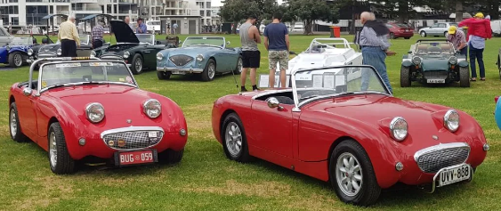

Cars will be on display from 9.30am, and this will be a chance to showcase both our vehicles and the Sprite Club of South Australia and The Austin Healey Owners Club of South Australia to the General Public and help celebrate classic car ownership.

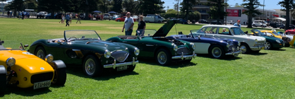

There will be People’s Choice Awards and our John Cronshaw will have his book stall, also there will be a coffee van on site adjacent to Anzac Highway. Bring a Picnic or go to the Orange Spot Bakery or Little Eatery or the Watermark Hotel for lunch. Stroll down to Jetty Road if you prefer an ice cream, come and make a day of it with likeminded Healey enthusiasts.

Please bring along your Sprite, Midget or Austin Healey as we would like to see as many vehicles as possible in restored or original condition, race or competition, or under restoration.

**Entry is Free to all Sprite, Midget and Austin Healey’s**, so if you would like to register your interest in attending or would like further information, please contact:

Ian Watson – [ianwatson52@gmail.com](mailto:ianwatson52@gmail.com) - 0409323016 or Jock Osborne – [jjosborne@adam.com.au](mailto:jjosborne@adam.com.au) - 0417884109

